MARKING SCHEME
ARISE & SHINE TRIAL 2- JULY – 2026
MATHEMATICS ALT A - 121/2
- No log
0.4239 4.$\overline{1.}6272$ 4.335$√A1$
149.6 2.1750$√M1$
1.9022 -
Log 6 = 0.778 $\overline{1}$.8911 $√$M1
  - 0.6370 $√$M1
3

__________________________________________________________________________________________

- $\frac{{ar}^{2}+{ar}^{3}}{{ar}^{3}+{ar}^{4}}$ = $\frac{8}{16}√M1$
, $\frac{{ar}^{2}(1+r)}{{ar}^{3}(1+r)}$= ½
. $\frac{{ar}^{2}}{{ar}^{3}}$ = ½
.$\frac{1}{r}$ = ½
r = 2
a.2² + a2³ = 8
4a + 8a = 8
12a = 8
a = ²/₁₂
a = ²/₃ B1
______________________________________________________________________________________

3. $\frac{\left(\sqrt{3}\right)+ 2\sqrt{\left(5\right)} (\sqrt{5}+\sqrt{\left(3\right)}}{\left(\sqrt{5}-\sqrt{3}\right)\left(\sqrt{5}+\sqrt{3}\right)}$
Num
. $\sqrt{15}+10+2\sqrt{15}$
13 + 3$\sqrt{15}$ $√$M1
Den
($\sqrt{5}- \sqrt{3})\left(\sqrt{5}+ \sqrt{3}\right)$
5-3 = 2
$\frac{13+3\sqrt{15}}{2}$ $√$M1
6.5 + 1.5 $\sqrt{15}$ $√$A1

4. $\frac{8.4}{\sin{68}}= \frac{x}{\sin{39}}$
x = $\frac{8.4}{\sin{68}} x\sin{39}$
= 5.701
‘$\frac{CN}{sn 68}= \frac{5.701}{\sin{75.5}}$ $√$A1
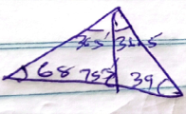
CN = $\frac{5.701}{\sin{75.5}}$ x sin 68 $√$M1
CN = 5.459
CN = 5.5 (1dp) $√$A1
__________________________________________________________________________________________
5. P = t – $\frac{s+Pk}{\sqrt{s+Pk}}$
. $\frac{\left(s+Pk^{2}\right)}{{\left(\sqrt{s+Pk}\right)}^{2}}$ = (t-p)²
, $\frac{{\left(s+Pk\right)}^{2}}{s+Pk}$ = $\frac{{\left(t-P\right)}^{ (S+Pk)}}{s+Pk}$
S+pk = (t-)p²
, $\frac{Pk}{p}$ = $\frac{{\left(t-p\right)}^{2}-s}{p}$ $√$M1
k = $\frac{{\left(t-p\right)}^{2}-s}{p}$ $√$A1
__________________________________________________________________________________________
6. Log₉$\frac{\left(x+5\right)}{\left(x-3\right)}$ ₌ Log₉ 9 ½ $√$M1
.$\frac{x+5}{x-3}$ = $\frac{3}{1}$
x+5 = 3x-9$√$M1
14 = 3x-x
14 = 2x
x = 7 $√$A1
__________________________________________________________________________________________
7. 3 = k + m -1
5 = ½ k +$\frac{m}{\frac{1}{4}}$
5² = ½k + 4m²
10 = k + 8m
3 = k + m
,$\frac{7}{7}$ $\frac{7}{7}$ m
M = 1 $√$A1
K = 2
P = 2$θ$+ $\frac{1}{θ^{2}}√$B1
_____________________________________________________________________________________
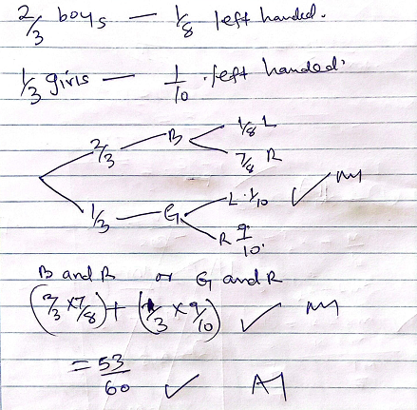
9. y = x³ – 4x² + 3x
^{dy}/_{dx} = 3x² – 8x + 3 $√$M1
3x² – 8x + 5= 0 $√$A1
x = 1 or x= ⁵/₃ $√$A1
y = 1 - 4 +3
(1,-1) $√$or (5/3)$√$B1
_________________________________________________________________________________________
10. (1+x)⁵ = 1⁵xº+1⁴x¹+1³x²+1²x³+1¹x⁴+1⁰x⁵
1 5 10 10 5 1
x=0.02
= 1+5x+10x²+10x³+5x⁴+x$√$M1
1+5(0.02)+10(0.02)²+10(0.02)³+5(0.02)⁴+(0.02)⁵
1.1040808$⇒$ 1.104 3dp
______________________________________________________________________________________
11. P = 3$\left(\begin{matrix}2 \\ 1 \\ -2\end{matrix}\right)$ - $1\left(\begin{matrix}-3 \\ 4 \\ -1\end{matrix}\right)$ + 2$\left(\begin{matrix}5 \\ 3 \\ 2\end{matrix}\right)$ $√$M1
$\left(\begin{matrix}6 \\ 13 \\ -6\end{matrix}\right)$ + $\left(\begin{matrix}-33 \\ -4 \\ 1\end{matrix}\right)$ + $\left(\begin{matrix}1q \\ 5 \\ -12\end{matrix}\right)$ $√$M1
/p/ = $\sqrt{9^{2}+5^{2}+{\left(-1\right)}^{2}}$
= $\sqrt{387}$
= 19.7 $√$A1
________________________________________________________________________________________
12. ${\left(\frac{1}{4}x^{4}+ x^{2}- 3x\right)}_{2}^{5}$ $√$M1
(¹/₄(5)⁴+5²-3⁽⁵⁾) – (¹/₄(2)⁴+2²-3(2) $√$M1
166 ¼ - (2)
= 164 ¼ $√$or 164.25 $√$A1
_________________________________________________________________________________________
13. A= ½ bxh
10.5 = ½ x 7h h = $\frac{10.5}{3.5}$ = 3cm
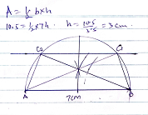
B1 line AB
B1 perpendicular
B1-For identifying G and C₂
__________________________________________________________________________________________
14. D = 450000 – 75000
375000
A = 375000 (1+¹⁵/₁₀₀ x ½)¹² $√$M1
A= 435282.944
Monthly installment $\frac{435282.944}{12}$ $√$M1
= 36274 $√$A1
________________________________________________________________________________________
15. (a) $\frac{47x10+58}{11}$ = 48$√$ $√$M1
__________________________________________________________________________________________
(b) 11 =$\sqrt{\frac{{Σfx}^{2}}{10}-{\left(47\right)}^{2}}$
121 = $\frac{{Σfx}^{2}}{Σf}$ -2209 B₁
$\frac{{ Σfx}^{2}}{Σf}$ =23300

New s.d =$\sqrt{\frac{23300}{11}+{58}^{2}- {48}^{2}}$ $√$M₁
= 10.95 $√$A₁
____________________________________________________________________________________
16. Period $\frac{360}{\frac{1}{2}}$ = 720º $√$ B1
Phase 70º$√$ B1
____________________________________________________________________________________
SECTION II
17. A = P (1 + ¹/₁₀₀)²
500,000 (1+⁸/₁₀₀)² = 583200$√$M1 substitution
Invested = ⁷⁵/₁₀₀ x 583200$√$M1attempt to find 75% of the amount
= Ksh 437400 $√$A1
(b)(i) A = 437400 (1 – ⁴/₁₀₀)² $√$M1
= Ksh 403107.84 $√$A1
(ii) 403107.84 (1+⁸/₁₀₀)¹² $√$M1
= 1015094.117 $√$A1
= Ksh.1015094 $√$B1 to the nearest shillings
c) gain $\left(\frac{1015094-437400}{437400}\right)$100% $√$M1
= 132.0745313%
= 132.07% $√$A1 Accept to 1 d.p
__________________________________________________________________________________
18. (a) Total taxable income
=30,000+15000+3500 $√$M1
= Ksh 48,500 $√$A1
(b) 1sst slab $\frac{10}{100} x 9680 ⇒ 968$ $√M1$
1nd slab = 9120 x $\frac{15}{100}$ $⇒$1368
3rd slab = 9120 x $\frac{20}{100}$ $⇒$1824 $√M1$
4th slab = 9120 x $\frac{25}{100}$ $⇒$ 2280
5th slab = 11460 x $\frac{30}{100}$ $⇒$ 3438
Ksh 9878 $√M1$
Less Relief 1056 $√M1$ subtraction
PAYE 8822 $√A1$-
c) 48500 – (882+1500+2500) $√M1$-All deduction
48500-12822 $√M1$ - subtraction
Net = income = 35,678 $√A1$
__________________________________________________________________________________________19 $.∠$PRS
$∠SPQ$ =90º-Agles on diameter
($∠$PSQ=70º=$∠$PRQ)
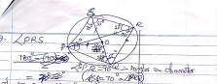
- $∠$PQS$⇒$ 180 – (90+70)
=20º
$∠$PRS = 20º Angles $√B1$
Subtended s by same chord are equal $√B1$
$∠$PQQ
$∠$POQ = $∠$PRQ
= 2x70
⁼140º $√B1$
Angle at centre is twice angle at the circumference $√B1$

c) $∠$QSR = 180 – (90+35)
=55º
$∠$PSR = 55+70
125º sum of interior angles of $∆s$add upto 180º
Alternative OR $∠$PQR =55
$∠$PSR = 180º-55º
= 125º $√B1$
Opposite angles of cylic quadrilaterals add up to 180º $√B1$
c) $∠$RPS
18º-(125+20)º
= 35º $√B1$
Sum of interior angle of $∆$add up to 180º $√B1$
e) $∠$POS
$∠$POQ = 140º (2 PSQ)
$∠$POS 40º (Acute angle
Reflex $⇒$360º – 40º
= 320º $√B1$
Angle at a point is 360º $√B1$

20. dist in nm long cliff = 20+40 = 60º
= 60x60 cos 60
= 1800nm
Time difference = 60x4=240 mins
= 4hrs
1300 + 400 = 1700 hrs
Time taken 2100 – 1700 = 400
$⇒$4hrs
Speed = $\frac{1800}{4}$ $√B1$
= 450 knots$√A1$
b)(i) long cliff 140º-20º
=120º
Dist =120ºx60cos 60
= 3600nm
Time taken =$\frac{3600}{500}$ = 7.2h $√B1$
= 7 hr 12 min $√A1$
Time at c when helicopter is at A$⟶$ long cliff = 120ºx4min
= 480min
=8hrs
1300 – 800 = 0500h
Time helicopter reach C
0500 – 712= 1212hr $√M1$
= 1212 hr $√A1$
ii 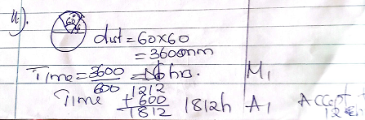
dist = 60x60
= 3600nm
Time =$\frac{3600}{600}⇒$6hrs $√M1$
Time 1212 + 600 1812
= 1812h $√A1$ Accept time in 12 hr system
__________________________________________________________________________________________
21.
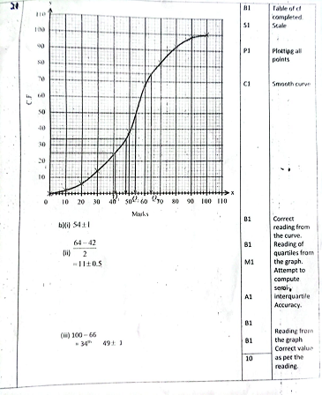
_________________________________________________________________________________________
22. Lsf = ¹⁸/₁₂ = ³/₂
³/₂ = $\frac{h+9}{h}$ $√M1$
3h-2h=18
h=18
H=18-9
27cm$√A1$
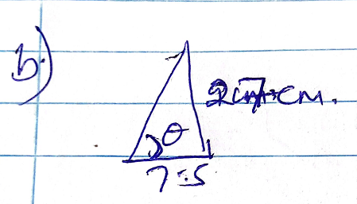
Tan$θ$ =$\frac{27}{7.5}$ $√M1$
.$θ$ = tan-1
=74.48º$√A1$
- TR = $\sqrt{{27}^{2}+{11.72}^{2}}$ $√M1$
= 29.43
$\frac{29.43}{l}$ = $\frac{3}{2}$
l = $\frac{29.43x2}{3}$ = 19.62
29.43 -19.62 = 9.81
, $\sqrt{{9.81}^{2}-9^{2}}$ = 3.903
Tan $θ$= $\frac{9}{19.54}$ $√M1$
, $θ$=24.74º $√A1$

- Diagonal PR = $\sqrt{{18}^{2}+{11.72}^{2}}$
= 23.43cm
= 11.715cm
Tan $θ$=$\frac{27}{11.715}$
= 66.54º
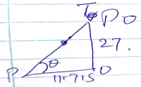
e) 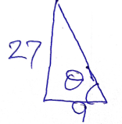 tan $θ$= $\frac{27}{9}$ $√M1$
$θ$= 71.57 $√A1$

24(a) a = ^{dv}/_{dt} = 5-4t $√A1$
5-4(2) $√M1$
5-8
= -3m/s² $√A1$
____________________________________________________________________________________
(b) . $\int_{3}^{4}{\left(3+5t-{2t}^{2}\right)dt}$
. ${\left(3t+\frac{{5t}^{2}}{2}-\frac{{2t}^{2}}{3}\right)}_{3}^{4}$
(3(4)+⁵/₂ (4)²-²/₃(4)³ – (3(3)+⁵/₂(3)²-²/₃(3)³) $√M1$
(12+40-¹²⁸/₃) – (13 ½ ) $√M1$
9 ¹/₃
4 ¹/₆ m $√A1$
_________________________________________________________________________________________
c)$\int_{0}^{3}{\left(3+5t-{2t}^{2}\right)dt}$
, ${\left(3t+{\frac{5t}{2}}^{2}-{\frac{2t}{3}}^{3}\right)}_{0}^{3}$ + 4 ¹/6 $√M1$
= 17 ²/₃ m $√A1$

__________________________________________________________________________________________
